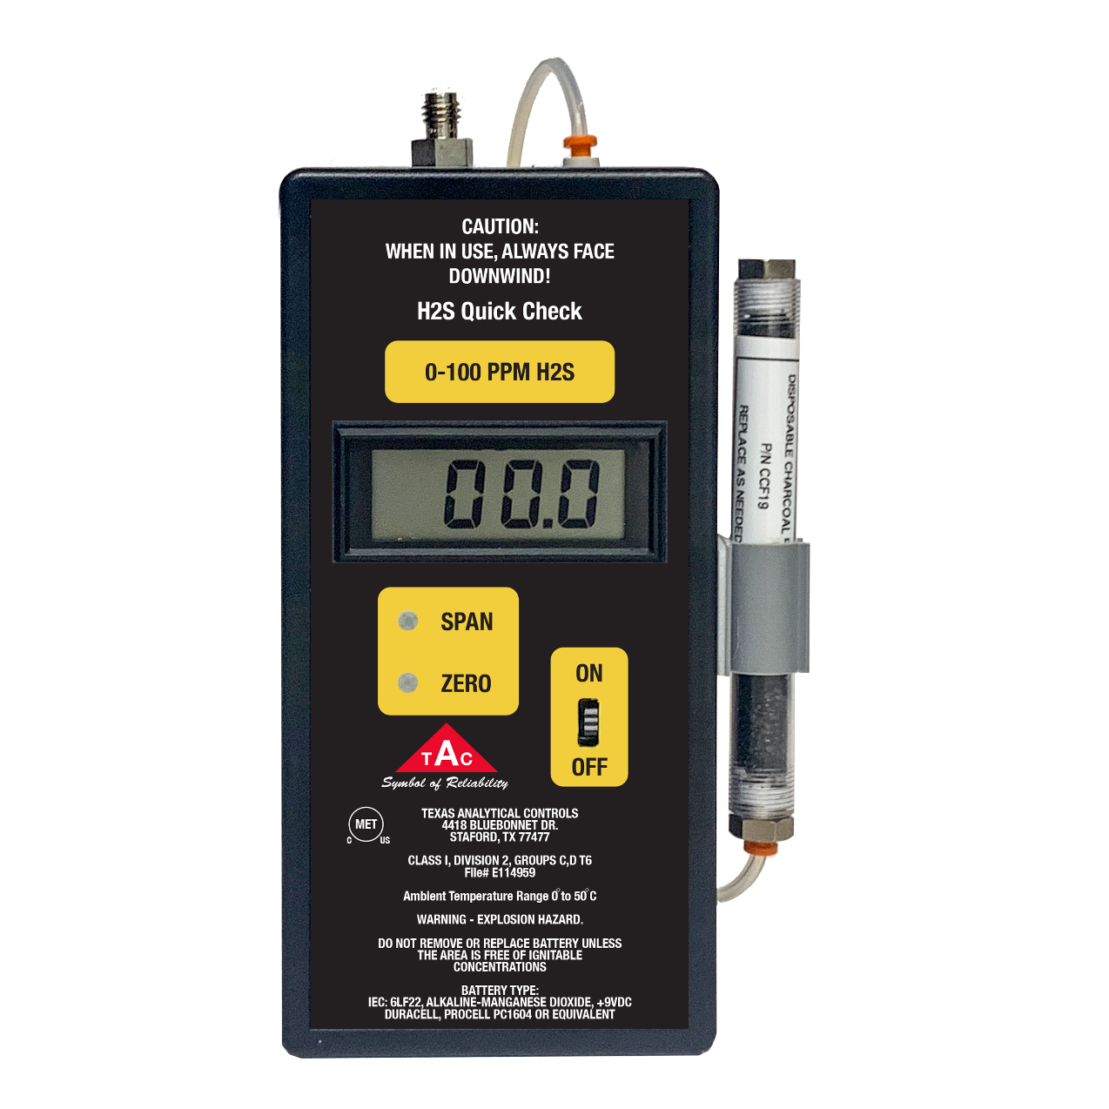
4

2020
Texas Analytical Controls
4418 Bluebonnet Dr
Stafford, Tx 77477
(281) 240-4160
www.tac-controls.com

2-10-20
H2S Quick Check
Table of Contents
1. INTRODUCTION 3
2. OPERATION/ SAMPLING 5
3. CALIBRATION/ BUMP TEST 7
4. ADJUSTING SPAN AND ZERO SETPOINTS 7
5. DRAWINGS 8
6. REPLACING THE H2S SENSOR 9
7. REPLACING THE BATTERY 9
8. REPLACING CHARCOAL FILTER P/N CCF19 10
9. RECOMMENDED SPARE PARTS 11
10. RECOMMENDED CALIBRATION SUPPLIES 11
11. SPECIFICATIONS 11
12. TROUBLESHOOTING 11

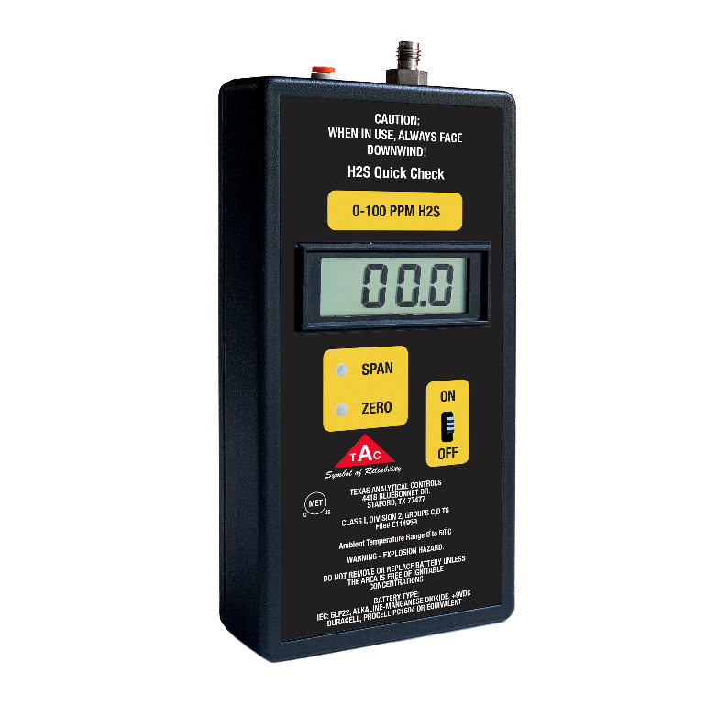
- INTRODUCTION

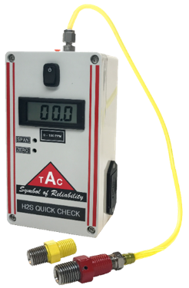
The H2S QUICK CHECK is a hand-held device designed to spot check the H2S levels in natural gas pipelines as well as verify the H2S concentration in calibration gas bottles.

The sample goes in the “Sample In” through the H2S sensor housing and out the “Sample Vent” fitting. Always use extreme caution when venting. A charcoal filter with tubing should be used to absorb any H2S that is vented from the sensor vent fitting located on the top of the monitor. Operators should routinely verify the charcoal is still absorbing by using an H2S monitor at the outlet.

The Quick Checks use an electro-chemical sensor to measure the levels of H2S. The sensor lasts approximately 2 years. Depending on how often the unit is used calibration should be done routinely. Calibration as well as sensor replacement can be done in the field or sent back to the factory. A Procell by Duracell 9v battery (PC1604 Alkaline Manganese Dioxide ) is used to power the unit. The 9V battery should never be replaced in a hazardous area.

WARNING – EXPLOSION HAZARD. DO NOT REMOVE OR REPLACE BATTERY UNLESS THE AREA IS FREE OF IGNITIBLE CONCENTRATIONS.

The Quick Check is available in 2 ranges: 0-100PPM and 100-2000PPM.

Each unit is in a rugged carrying case with the following parts:

P/N 222 Sample Orifice w/ tubing (3’)
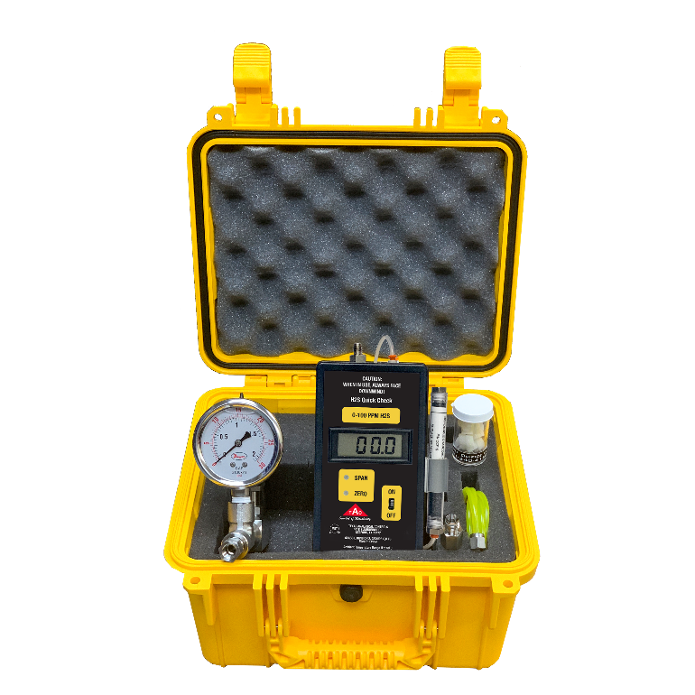
P/N CGF Calibration Gas Fitting
P/N ORF Orifice Filters
P/N CC19 Charcoal Filter
P/N SS19 Sample System: includes 1 Needle Valve w/ 30# Gauge

Upon Receipt:
After unpacking check the equipment to make sure nothing was damaged during the shipping process.
If any damages occurred call Texas Analytical Controls at 281-240-4160 within 3 working days.

Insert the 9V battery in the equipment when ready to use. Always remove the battery when the equipment is not in use. The 9V battery should never be replaced in a hazardous area.

- OPERATION/ SAMPLING

Safety First: Always remember safety comes first when working in an H2S environment. Improper use of the H2S Quick Check could result in bodily harm or death.

H2S is a colorless, flammable extremely hazardous gas. Always ensure adequate ventilation. Use appropriate ventilation as required to keep the Exposure Limits in Air below TLV and PEL limits. Be aware of any signs of dizziness or fatigue. If necessary, use appropriate respiratory protection and any other necessary personal protective equipment (PPE).

Extreme caution should always be used when taking a sample.

A regulated sample free of contaminates is required to get accurate readings when using a Quick Check.

Prior to connecting the Quick Check purge the sample/ball valve. The purging will help mitigate any contaminates from getting into the sample orifice.
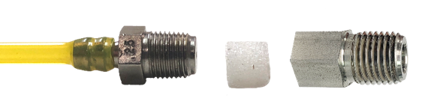
If contaminates are an issue, a disposable orifice filter can be inserted into fitting to keep the orifice from getting obstructed. Use the provided flat screwdriver to easily replace the orifice filter. (Replace the orifice filter as needed to keep a clean sample)

Insert the 9V battery. Use the slide switch to turn the unit on. Each unit has a 3- ½ LCD Display. When the display reads Zero it is ready to use.

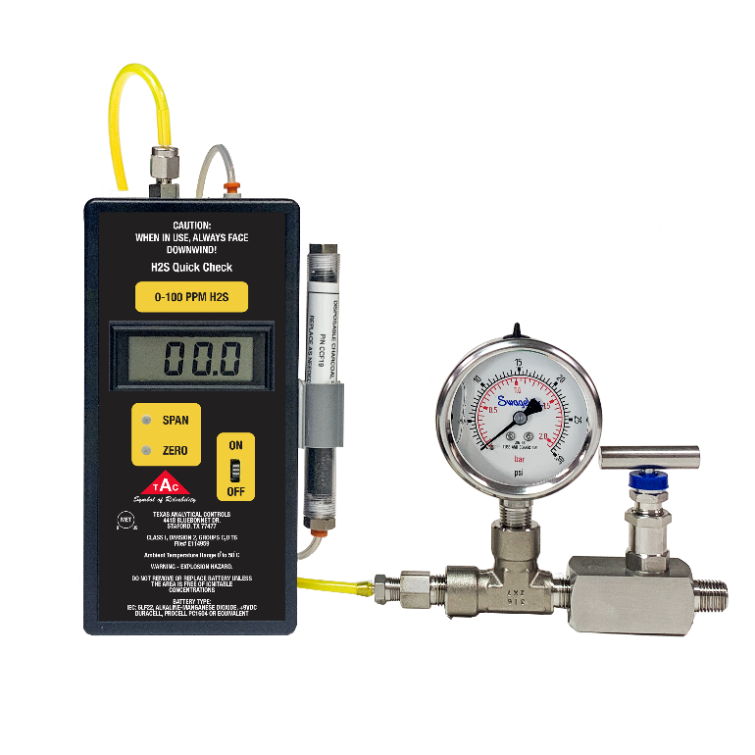
The sample flows from the operator’s sample point to the needle valve with the 30# gauge assembly through the sample orifice through the H2S housing then vented. For operator’s protection a charcoal filter should always be used to absorb any H2S vented. For a Low Range Quick Check with no H2S present in the atmosphere it should be read zero in less than 30 seconds. The High Range unit will take approximately 2 minutes to reach zero.
Set at 10 PSIG

After each reading disconnect the sample line this allows the unit to clear. Failure to disconnect the line can cause false readings due to residual gas still present in the line from the previous sample.

Note: Extreme differences in pressure/flow rates from one sample point to another can affect the readings.

The sample goes in the “Sample In” through the H2S sensor housing and out the “Sample Vent” fitting. Always use extreme caution when venting. A charcoal filter should be used to absorb any H2S that is vented from the monitor. Operators should routinely verify the charcoal is still absorbing by using an H2S monitor at the outlet. The charcoal filter should be replaced as needed.
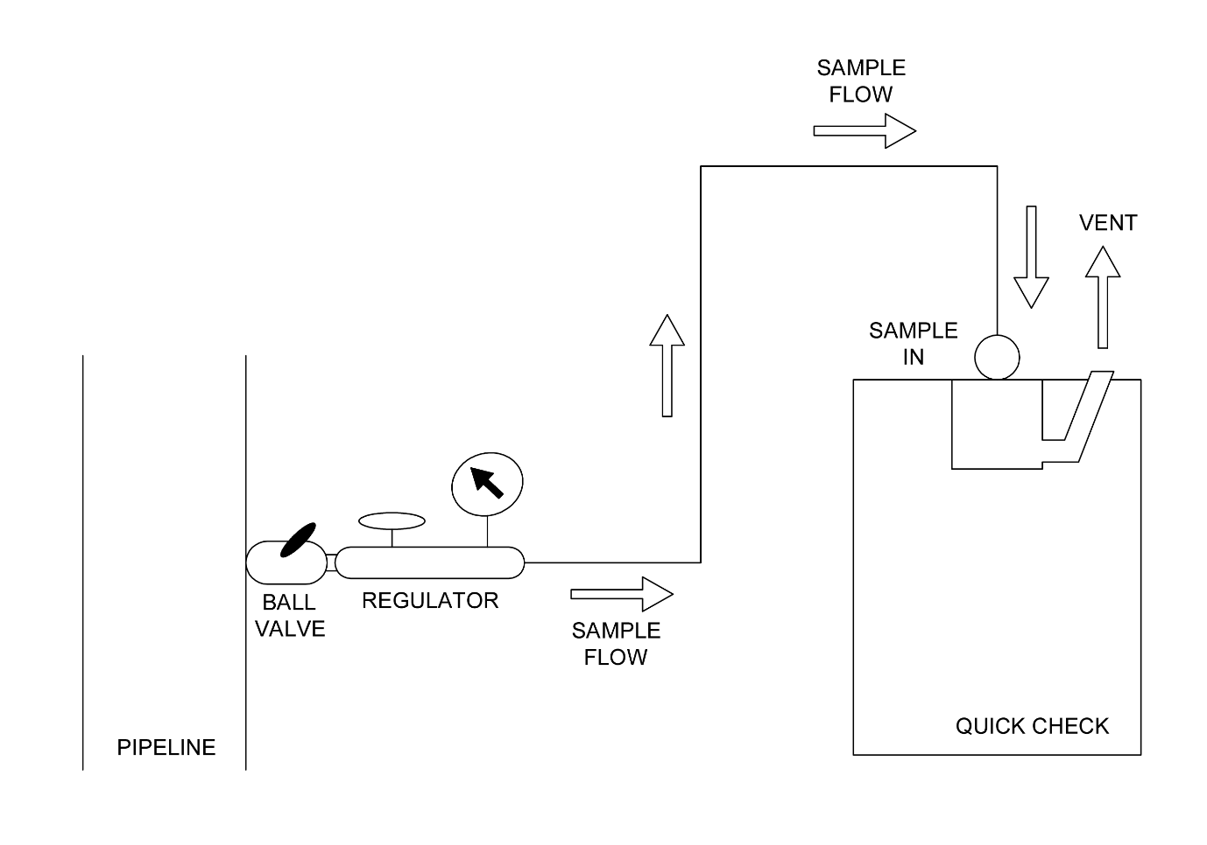
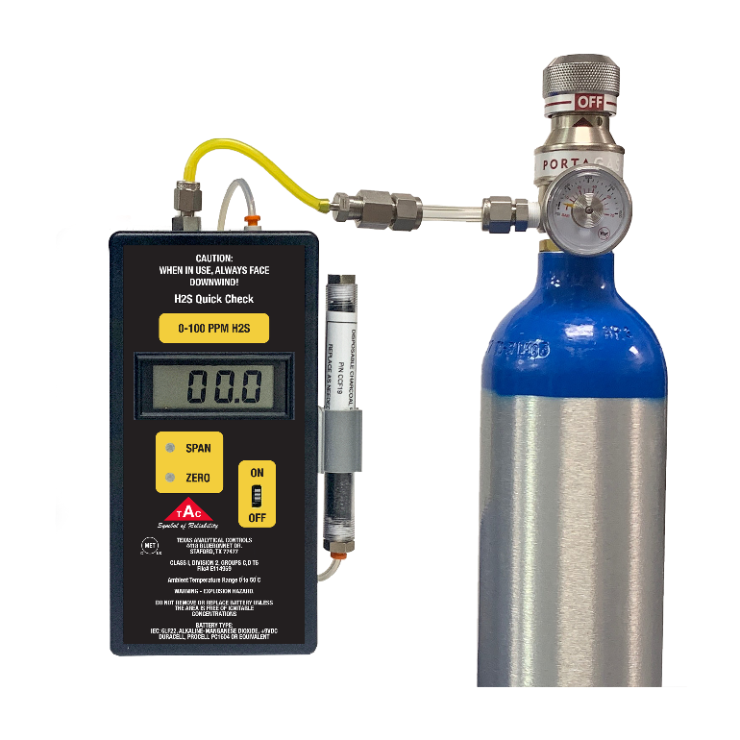
- CALIBRATION/ BUMP TEST

Periodic calibration and maintenance of the Quick Check is required for proper operation and correct reading.
Depending how often the unit is used determines the calibration frequency. Customers can purchase a certified H2S calibration bottle to bump test/calibrate the unit. The regulator and calibration gas can be provided by Texas Analytical Controls.

For the Quick Check 0-100PPM the recommended concentration is 10PPM H2S Balance N2.

For the Quick Check 100-2000PPM the recommended concentration is 500PPM H2S Balance N2.

For safety purposes calibration/bump tests should always be performed under a vent hood. A charcoal filter should be attached to the vent line to absorb the H2S vented during the calibration process.

The Quick Check can also be returned to the TAC factory for routine calibration. For the first year, TAC will calibrate the unit at no charge.

- ADJUSTING SPAN AND ZERO SETPOINTS

The Span and Zero pots are used to calibrate and set the zero. Each one has a plastic cover to protect the unit while it is used in an outdoor environment.

The Span and Zero pots should be adjusted in an area with no H2S is present in the atmosphere. Turn the unit on and wait for the display to read 00.0. Use the provided flat head screwdriver to adjust the potentiometer until it reads 0.00. Use the Zero pot make adjustments to the zero reading. Use the Span pot to make adjustments when a certified calibration standard is applied.

- DRAWINGS

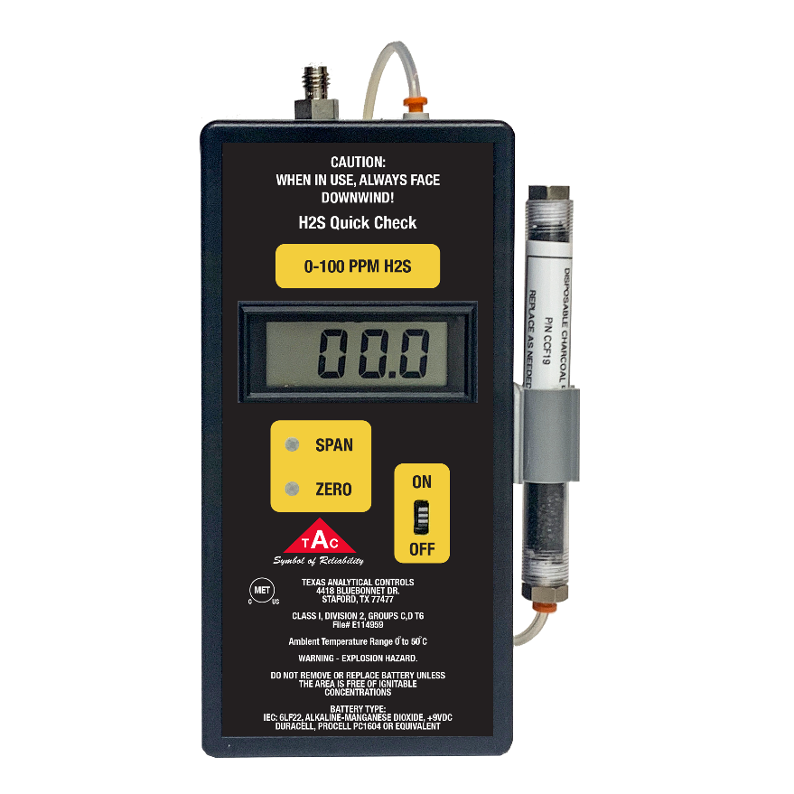
SAMPLE
VENT
SAMPLE IN FITTING

CHARCOAL FILTER

ON/OFF SWITCH
9V BAT DOOR
ZERO POT

SPAN POT

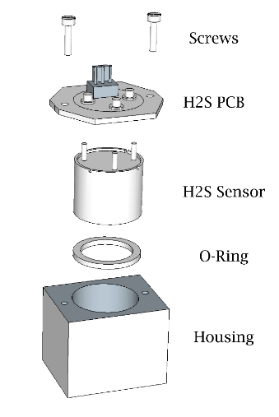
- REPLACING THE H2S SENSOR

Replace the H2S sensor in an environment free of H2S.
Turn the Quick Check to the “OFF” position and remove the 9v battery.

Use the provided screwdriver to unscrew the four screws holding the unit together.

Use the same screwdriver to remove the 2 screws holding the sensor board to the sensor housing. Gently remove the sensor from the printed circuit board and replace the sensor. Recalibrate the unit each time the sensor is replaced. (See drawing for details)

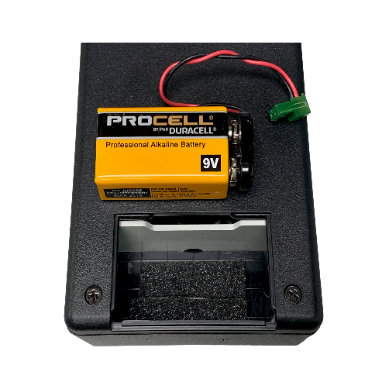

- REPLACING THE BATTERY

The 9V battery is located in the back of the monitor in a self-contained portion of the enclosure.

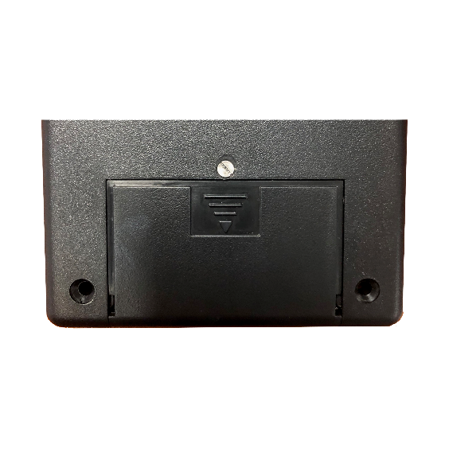

A screwdriver is provided to unscrew the slide door to replace the battery.

NOTE: The battery should never be replaced in hazardous location.
Turn the unit to the “OFF” position when replacing the battery.

WARNING – EXPLOSION HAZARD. DO NOT REMOVE OR REPLACE BATTERY UNLESS THE AREA IS FREE OF IGNITIBLE CONCENTRATIONS.

- REPLACING CHARCOAL FILTER P/N CCF19

The charcoal filter is a disposable filter. It is used to absorb the H2S.
A H2S Monitor should used be regularly to test the charcoal filter to make sure It is still absorbing

Warning: Charcoal may be harmful is inhaled, swallowed or absorbed through skin.
Avoid contact with skin and eyes. In case of contact, rinse with plenty of water.

- RECOMMENDED SPARE PARTS

9V Battery Procell by Duracell PC1604 Alkaline-Manganese Dioxide
P/N 222 Hose Barb w/Orifice
P/N CCF19 Charcoal Filter
P/N ORF Orifice Filter
P/N 6S Low Range H2S Sensor
P/N 6AE High Range H2S Sensor

- RECOMMENDED CALIBRATION SUPPLIES

QUICK CHECK 0-100PPM

10PPM H2S Calibration Gas balance N2
P/N 116ES9810PPM
Calibration Gas Regulator with tubing and fitting
P/N CGR-1

QUICK CHECK 100-2000PPM
500PPM H2S Calibration Gas balance N2
P/N 116ES98500PPM
Calibration Gas Regulator with tubing and fitting
P/N CGR-1

- SPECIFICATIONS

Target Gas Hydrogen Sulfide
Detection Range 0 to 100 PPM & 100 to 2000 PPM
Accuracy +/- 2% of the reading
Operating Temperature 0-50 Degrees C
Power 9V Procell by Duracell Battery
Construction (Housing) Polycarbonate
Dimensions 6.7 in L x 3.3 in W x 6.7 in H
Weight 12 oz
Altitude Up to 2000 meters

- TROUBLESHOOTING

No Display:
Action1: Replace the 9v Battery.
Action 2: If the display still does not come on return to the factory

The Quick Checks have a slow response time or does not respond
Action 1: Replace the Sample Orifice most likely obstructed due to contaminates.
Action 2: Replace the H2S Sensor.
Action 3: Send back to the factory.

